Yale Club of Washington, DC Presents:

ANTIETAM & GETTYSBURG

June 25 - 29, 2025

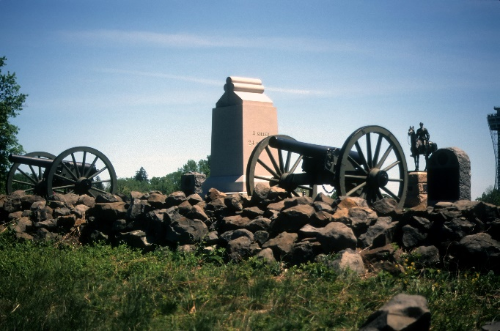Join other Yale Alumni, their friends, and families on a five-day guided tour of the battlefields of Antietam and Gettysburg representing Lee’s 1862-1863 northern incursions and the turning point of the Civil War. The trip will include illustrated talks by Yale History PhD and Civil War scholar Brian Matthew Jordan. You will stay in the historic Gettysburg Hotel ([www.hotelgettysburg.com](http://www.hotelgettysburg.com)), a four-star hotel in the heart of the old town.

The tour begins with a welcome reception and dinner at our hotel. On three successive days, you will visit the battlefields leading to the most pivotal battles in the Civil War and see special historical sites not otherwise open to the general public. Each morning features illustrated lectures describing the day’s fighting before we visit the battlefields.

# Lecturer

**Brian Matthew Jordan,** Yale ’13 Ph.D., and Associate Professor of History and Chair of the History Department at Sam Houston State University in Huntsville, Texas. Dr. Jordan will provide several morning talks and guide the afternoon battlefield motor coach tours. An expert on the military and political history of the Civil War, Dr. Jordan’s scholarship has also explored the trials of homecoming faced by Union soldiers—a topic all too familiar to American society today, as our serving men and women return home from conflict. He is the author of *Marching Home: Union Veterans and Their Unending Civil War* (Liveright/W.W. Norton, 2015), which was a finalist (one of three runners up) for the 2016 Pulitzer Prize in History. His latest books include *A Thousand May Fall: Life, Death and Survival in the Union Army* (2021) and *Final Resting Places: Reflections on the Meaning of Civil War Graves* (2023). He has earned accolades for his work in the *Washington Post* and *Wall Street Journal* and has appeared on the HISTORY Channel and C-SPAN.

# Space Limited. [Register Now](https://www.eventbrite.com/e/the-civil-war-road-gettysburg-antietam-tickets-1017106963307?aff=oddtdtcreator)!

The cost per person is $2,419.00, double occupancy, with a single supplement of $793.00 Payment due by January 24, 2025 and is non-refundable after February 21, 2025 with a 5% discount for registration before November 15, 2024. Register online at . The Club accepts payment by credit card ([Eventbrite](https://www.eventbrite.com/e/the-civil-war-road-gettysburg-antietam-tickets-1017106963307?aff=oddtdtcreator)) or check. Included in the registration price are:

* Welcome cocktail reception and farewell dinner.
* 3 dinners, 4 buffet breakfasts and 3 box lunches.
* Motor coach transportation to and from the battlefields and other sites.
* Admission to National Battlefield Parks, including the museums, movies and the Gettysburg Cyclorama.
* Autographed copy of *Marching Home: Union Veterans and Their Unending Civil War*

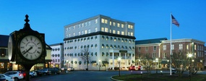Not included in the registration price are:

* Personal gratuities; non-scheduled excursions; wines, liquors, and mineral waters (unless specified).
* Friday dinner on your own when participants are given the chance to sample Gettysburg’s varied restaurants (some of which require reservations) in various price ranges with some discount coupons provided.
* Parking or other charges for vehicles; and all items of a strictly personal nature.
* Travel insurance (highly recommended because life is uncertain.)

In addition, in advance of the tour, you will be provided with suggested readings and information on other local Gettysburg attractions and events. Printed materials will be provided for the lectures and tours.

# Detailed Itinerary (Times are approximate. This schedule subject to change.)

**Wednesday, June 25, 2025 Arrival in Gettysburg**

You may check in anytime after 4:00 pm at the Gettysburg Hotel, One Lincoln Square, Gettysburg, PA (717) 337-2000. Meet your fellow learners at the Welcome Reception, followed by a buffet dinner. Enjoy a great night’s sleep in your four-star accommodations.

6:00 pm Welcome Reception with complimentary wine, beer and cocktails

7:30 pm Seated dinner

9:00 pm Lecture: “And the War Came”

Overnight Gettysburg Hotel

**Thursday, June 26, 2025** **The Bloodiest Day: Antietam**

After breakfast, we will gather in the classroom for a lecture to set your understanding of the war’s early years—and the factors that led General Robert E. Lee’s army to splash across the Potomac in the fall of 1862. Then board our luxury motorcoach for a beautiful drive into Maryland. We will visit Antietam, the site of the titanic showdown that remains the bloodiest day in American history with 23,000 casualties. The tour will involve a mixture of coach travel and walking, so wear comfortable shoes. The coach returns to the hotel about 6:00 pm, giving you plenty of time to freshen up before a seated dinner at the hotel. The rest of the evening is at your disposal.

7:00 am Breakfast Buffet

7:45 am Lecture, “The Road to South Mountain & Antietam”

9:00 am Depart for Antietam National Battlefield

10:30 am Tour Antietam National Battlefield (bus & minimal walking)

1:30 pm Box lunch picnic in Keedysville, Maryland

2:30pm Tour Antietam National Battlefield (bus & minimal walking)

4:45 pm Depart for Gettysburg

6:00 pm Arrive in Gettysburg

8:00 pm Buffet dinner

Overnight Gettysburg Hotel

**Friday, June 27, 2025** **Gettysburg**

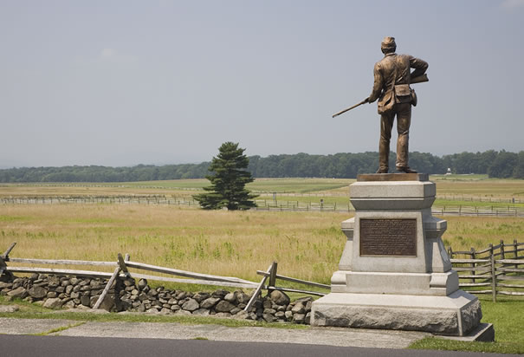Breakfast is followed by a lecture that takes the armies from their showdown at Sharpsburg to the crossroads of Gettysburg. We begin with a visit to the Gettysburg National Military Park Visitors’ Center, to view exhibits, an orientation film, and the cyclorama painting. After a picnic lunch, we will visit the fields of the first day’s battle. The coach heads back to the hotel at 4:45, allowing you time to explore the historic downtown. Select one of the outstanding restaurants nearby for dinner.

7:30 am Breakfast Buffet and Lecture, “From Antietam to Gettysburg”

9:00 am Depart for Gettysburg National Military Park Visitors’ Center

10:00 am Tour Visitors’ Center and View Orientation Film and Cyclorama Painting

12:00 pm Picnic Lunch

1:00 pm Depart Gettysburg National Military Park Visitors’ Center

1:30 pm Tour Battlefield of July 1

4:45 pm Depart for hotel

Evening Dinner on your own

Overnight Gettysburg Hotel

**Saturday, June 28, 2025** **Gettysburg**

Our breakfast is followed today by an early departure for the battlefield, where we will visit the fields contested on July 2-3, 1863 following in the footsteps of the men who stormed Little Round Top and made Pickett’s Charge. Back at the hotel for one last night, we have a farewell dinner and lecture that will consider the legacies and consequences of the war.

7:30 am Breakfast buffet

9:00 am Lecture, “The Human Face of Battle”

10:00 am Depart for Gettysburg National Military Park

10:15 am Tour Gettysburg National Military Park (bus & minimal walking)

12:00pm Picnic Lunch on the Battlefield

1:00 pm Continue tour of Gettysburg National Military Park (bus & minimal walking)

5:00 pm Depart for hotel

7:30 pm Seated Farewell dinner

9:00 pm Lecture, “The Long Shadow of the Civil War”

Overnight Gettysburg Hotel

**Sunday, June 29, 2025** **Departure from Gettysburg**

7:30 am Farewell Breakfast buffet

11:00 am Checkout deadline

GENERAL TERMS AND CONDITIONS

Health:

All participants should be in good health and capable of walking, sometimes over steep or rough terrain, and climbing stairs. By forwarding the deposit, the participant certifies that he/she does not have any physical or other conditions of disability that would create a hazard for him/her or other participants. The Yale Club of Washington, D.C, reserves the right to decline to accept or retain any person as a tour participant should such a person's health, mental condition, physical infirmity, or attitude jeopardize the operation of the tour or the enjoyment of the other participants.

By registering and attending, each participant hereby accepts all risk to their health and of injury or death that may result from participation in this Yale Club event (“Event”), including exposure to or harm from COVID-19 or other illnesses.

Exclusions. Personal gratuities; non-scheduled excursions; wines, liquors, mineral waters and meals not mentioned in this brochure under included features; laundry and dry cleaning; parking or other charges for vehicles**;** travel insurance; all items of a strictly personal nature.

Insurance: ***We highly recommend travel insurance as the cancellation penalty in the brochure will apply*.**  However, the Yale Club of Washington, D.C. does not recommend a particular insurance company.  Yale travelers are free to purchase the insurance through a company of their choice. Travel insurance companies may only offer a limited timeframe (7-21 days) within which to purchase travel insurance, otherwise certain restrictive provisions applicable to coverage may apply, such as pre-existing condition coverage or you may not be able to purchase it afterwards.  If travel insurance is important to you, you should not delay in purchasing insurance.

Cancellations and Refunds:

Payment due by January 24, 2025. All cancellations must be made in writing to the Yale Club of Washington, D.C. All payments are non-refundable as of February 21, 2025. When the Yale Club of Washington, D.C. receives written notification of cancellation, no further charges will be made to you. All refunds are subject to a $75 processing fee.

To the extent that payments made exceed the scheduled amount, funds will be refunded to you. No refunds will be given for cancellation that occurs subsequent to February 16, 2025. No refunds will be given for unused portions of the program (including, but not limited to, unused meals, hotel nights, and sightseeing), for any reason.

Responsibility:

The Yale Club of Washington, D.C. (hereafter called the "Program Sponsor") is responsible only for assisting in making arrangements with respect to all transportation, hotels and other matters of reservations and tour operations and it does not represent or act as agent for transportation carriers, hotels and other suppliers or services connected with this tour. The Program Sponsor assumes no responsibility for loss, damage, injury, accident, delay or other irregularity, expense or delays arising from sickness, diseases, pilferage, labor disputes, machinery breakdown, quarantine, government restraints, war, acts of terrorism, weather conditions or such other causes. All such losses or expenses shall be borne by the tour participant. Baggage and personal effects are the sole responsibility of the owners at all times. It is understood that tickets when issued shall constitute the sole contract between the passenger and carrier concerned. All services are subject to the laws of the state and country in which they are rendered.

Dates, schedules, program details, and costs are given based on information available and currently in force and are subject to change and revision. As a condition to acceptance of any application, each applicant represents that he or she has read the schedule of activities for this tour and recognizes and accepts any risks thereof and hereby agrees for and on behalf of himself or herself and his or her heirs, executors and administrators to abide by the conditions set forth above, and to release and hold harmless the Program Sponsor and its directors, governing board members, officers, agents, licenses, representatives, heirs, executors, administrators, successors, and assigns from any and all liability, claims and demands, however caused, for delays, damages, loss, illness, injury or death, occurring in relation to the tour, and for loss of or damage to his or her property, however occurring, in relation to the tour. Liability for luggage is strictly limited, and participants are urged to take necessary insurance for their protection.

If, due to weather or other uncontrollable factors, you are required to spend an additional night(s), each participant will be responsible for his or her own hotel, transfers and meal costs.

The Program Sponsor reserves the right to change the itinerary or trip features at any time and for any reason with or without notice, and shall not be liable for any such changes. All fares, as well as hours of arrival and departure, special programs and guest lecture series (if applicable), are subject to change without prior notice. The Program Sponsor shall not be required to refund any portion of the program price or make any other compensation under these circumstances. The Program Sponsor is not responsible for costs resulting from transportation and/or itinerary changes to and from the tour.

**Arbitration**:

In the event that a dispute arises between a participant and the Yale Club of Washington, D.C. or any other organizers of the trip, the following terms will apply: (a) the dispute will be settled by binding arbitration administered by the American Arbitration Association in Washington, D.C. which shall be the exclusive resolution method; (b) the dispute will be governed by District of Columbia law; (c) the maximum amount of recovery to which a participant shall be entitled under any and all circumstances will be the sum of all monies actually received from the participant by the Yale Club of Washington, D.C. The participant agrees that this is a fair and reasonable limitation on the damages, of any type whatsoever, that a participant may suffer.

**Agreement to Terms**:

Payment by tour participant(s) indicates acceptance of the above terms and conditions.